Introduction:

Assignment 4

Team 6

This report details the work for Assignment 4, which is a direct continuation of Assignment 3. In the previous assignment, the SeqTrack model was trained on two custom classes (coin and mouse) from the LaSOT dataset.
The goal of this assignment is to use the checkpoints saved from both training phases to perform a full inference and evaluation. This report presents the resulting performance metrics—specifically IoU (Success), Precision, AUC, and inference speed (FPS)—for each epoch. The findings are compiled into the required tables and graphs to analyze the model's performance.

Links:
Github:
https://github.com/Yahia-Ragab/Image-Processing-Projects/tr ee/main/Assignment%204

Dataset:
Uses lasot coin and mouse classes. The videos were made for testing according to the dataset is (coin-3, coin-6, coin-7, coin-18, mouse-1, mouse-8, mouse-9, mouse-17)

Environment:
Python:3.10 Linux arch Rtx 2050
threads:3 (more than that the machine freezes)
Num_gpus: 1 (more than that sometimes it shows cuda out of memory or cuda not found despite it once ran on 2)
The reset of the environment modules review assignment 3: https://github.com/Yahia-Ragab/Image-Processing-Projects/tr ee/main/Sheet2_assignment3

Code:
The lib/test/evaluation/lasotdataset.py edit to make it only test on the testing classes not all of the dataset (after first 4 checkpoints -see the reflection section for more details)
Just replace the test folder with the one inside the zip folder and everything is alright.

Run the code:
Run the testing using shell script you will find two files one called run_inference.sh for phase one checkpoints and run_inference_phase2.sh for phase two checkpoints of the training. Be on the root folder (SeqTrack) open the terminal inside it and run ./run_inference.sh or the other one based on what you want to do. It will reduce two outputs: one log file inside the root folder and folder /tracking/results/seqtrack/ inside it, the first the results file and the time file for each video.

Run the analysis:
Run this code in the terminal inside the root folder: Phase1: #
1. Go to results folder and link Phase 2 data cd
/home/yahia/VideoXbackup/SeqTrack/tracking/re sults/seqtrack/
rm seqtrack_b256_* 2>/dev/null # Clear old links
ln -s phase2/seqtrack_b256_* . # Link Phase
2 folders

# 2. Go back to root and run analysis cd /home/yahia/VideoXbackup/SeqTrack/ conda activate seqtrack
python tracking/analysis_phase2.py Or
python tracking/analysis_phase1.py

Tables:

Phase1:
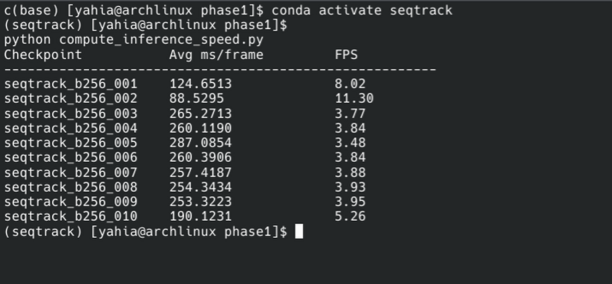
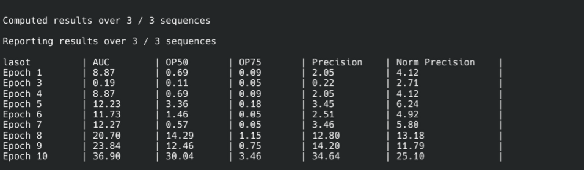

Phase2
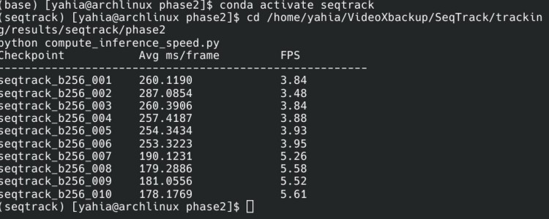

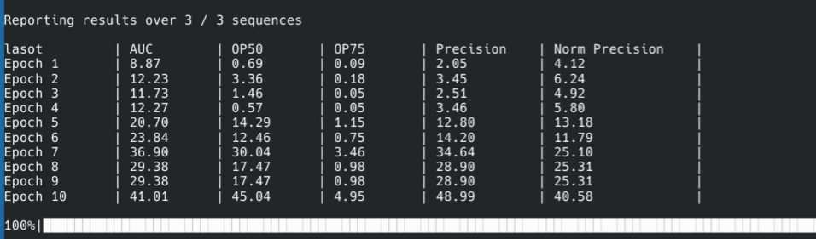
The values from epoch 4 to 10 in phase 1 is the same as from epoch 1 to 7 in phase 2

Graphes: Phase1
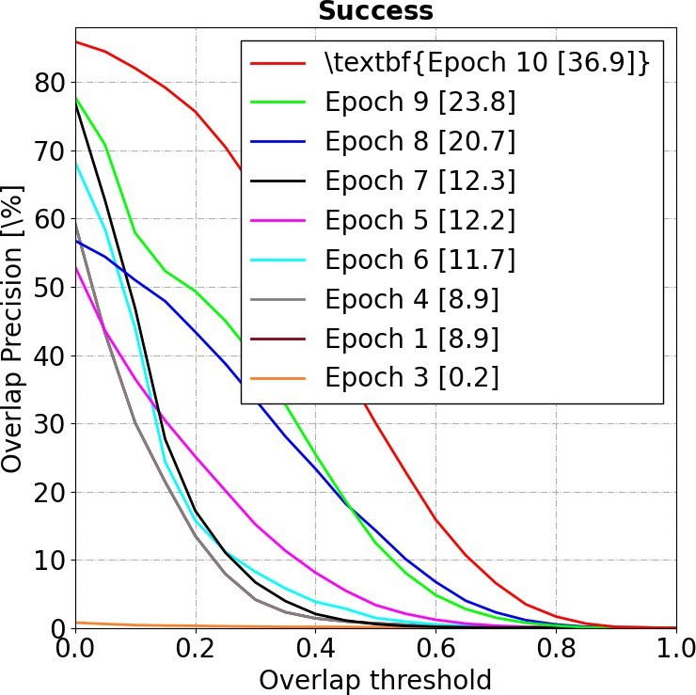

Figure 1: Success Plot
- Metric: Success, measured as Overlap Precision [%], against an Overlap Threshold (ranging from 0.0 to 1.0).
- Explanation: This graph shows the percentage of frames where the Intersection over Union (IoU) between the

predicted bounding box and the ground truth bounding box exceeds a certain threshold. A higher curve indicates better performance. The legend shows the Area Under the Curve (AUC) for each epoch, which is a standard aggregate measure of success.

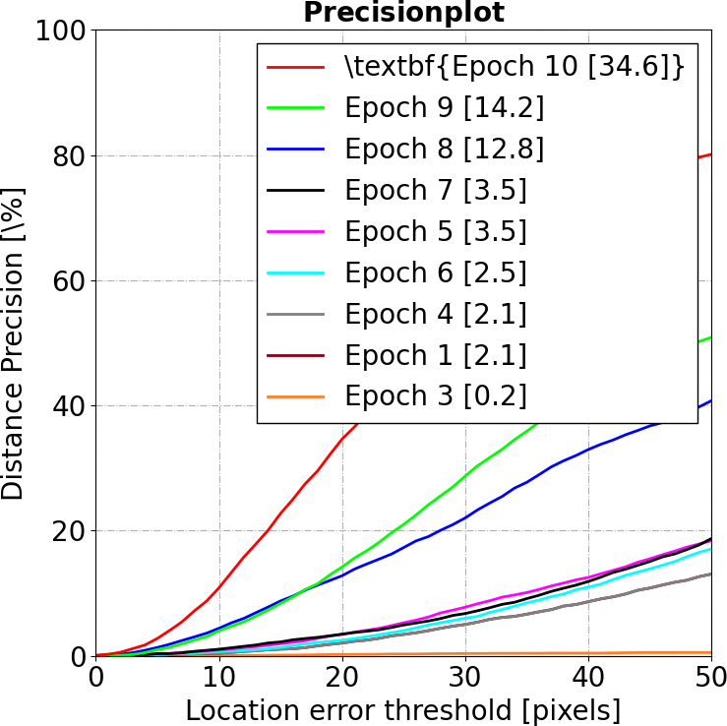

Figure 2: Precision Plot

- Metric: Precision, measured as Distance Precision [%], against a Location Error Threshold in pixels (ranging from 0 to 50).
- Explanation: This graph shows the percentage of frames where the distance between the center of the predicted bounding box and the center of the ground truth bounding box is within a certain pixel threshold. A higher curve indicates better precision. The legend displays the precision score at a standard threshold (often 20 pixels).

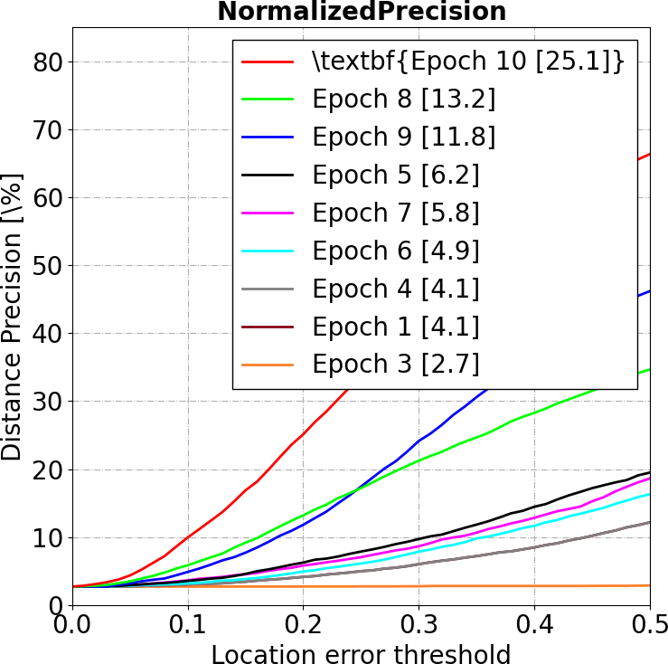

Figure 3: Normalized Precision Plot
- Metric: Normalized Precision, plotted against a Location Error Threshold (normalized, ranging from 0.0 to 0.5).
- Explanation: This is similar to the standard precision plot but normalizes the location error relative to the

object's size. This metric is useful because it's less sensitive to the target object's scale.
Phase2:
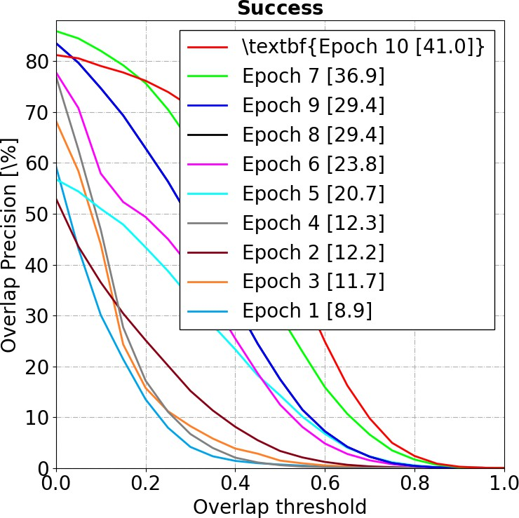

- Success Plot (Overlap Precision)
  - What it measures: This graph evaluates how well the predicted bounding box overlaps with the ground truth

box (Intersection over Union - IoU). The X-axis is the strictness of the overlap required (from 0% to 100%), and the Y-axis is the percentage of frames that passed that threshold.
  - Key Observations:
    - Best Model: Epoch 10 is superior with an Area Under Curve (AUC) of 41.0%, meaning it consistently maintains higher overlap across all difficulty levels.
    - Progression: There is a massive performance jump between Epoch 6 (23.8%) and Epoch 7 (36.9%).
    - Poor Performers: Epochs 1-4 perform poorly (below 13%), indicating the model had not yet learned to size or locate boxes accurately.

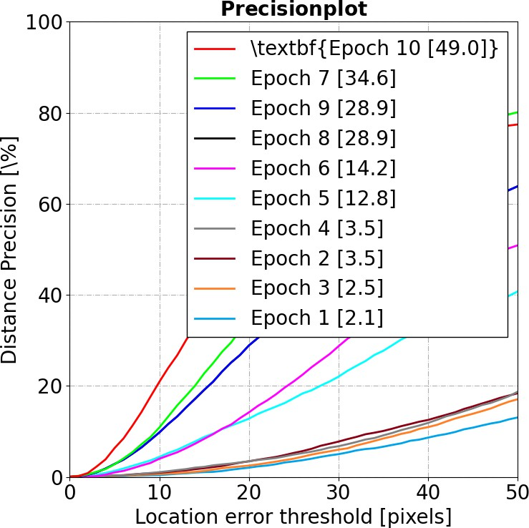

- Precision Plot (Distance Precision)
  - What it measures: This evaluates how close the center of your predicted box is to the actual target center, measured in raw pixels (0 to 50px error threshold on the X-axis).
  - Key Observations:

    - Best Model: Epoch 10 leads significantly with
49.0% precision at the standard 20-pixel threshold.
    - Progression: The gap between Epoch 9 (28.9%) and Epoch 10 (49.0%) is very large, suggesting a major breakthrough in localization accuracy during that final epoch of this phase.
    - Poor Performers: Early epochs are nearly flatlined at the bottom, meaning they rarely guessed within 50 pixels of the target.

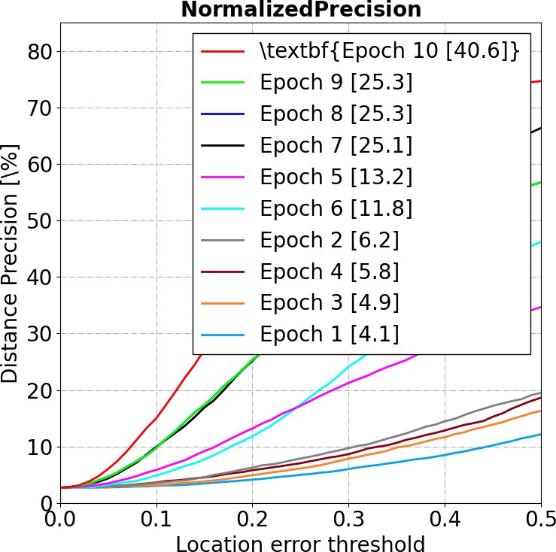

- Normalized Precision Plot
  - What it measures: Similar to the Precision Plot, but it adjusts the error relative to the target's size. This ensures that a 10-pixel error on a tiny mouse is penalized more than a 10-pixel error on a large coin.
  - Key Observations:

    - Best Model: Epoch 10 achieves 40.6%, confirming it is accurate regardless of whether the target is large or small.
    - Consistency: The ranking of epochs is consistent across all three graphs, confirming steady (and sometimes rapid) learning, with Epoch 10 being the definitive best checkpoint in this phase.

Reflection:
This assignment gave a practical and complete view of the machine learning pipeline, building directly on the training and checkpoint steps from Assignment 3. Adapting the test and evaluation scripts from the repository was not difficult, but the main challenge was the amount of time needed for inference.
I tried to run the model on all classes as requested, but the process was extremely slow. For example, running just the first four videos took around twelve hours, and I could not understand why it was so slow. To make the process more manageable, I decided to only run the evaluation on the test classes listed in the LaSOT dataset (https://huggingface.co/datasets/l-lt/LaSOT/blob/main/testing_ set.txt), which were skipped in the previous task.
For each of the 10 epoch checkpoints, I ran the evaluation over 40 video sequences (2 classes × 20 videos). Each video generated two output files (bounding box predictions and timing statistics), so the full evaluation created more than 800

result files in total. This required a lot of time and computing power.
This work showed me an important real-world lesson: producing evaluation data can be one of the hardest and slowest parts of a machine learning project. It also helped me understand the value of automation, good scripting, and patience when working with full end-to-end model evaluation.

